# Snowflake Hands-On Workshop

## Real-time Analytics with External Data

### September 10, 2019

1. Sign up for free Snowflake trial - <https://trial.snowflake.com/>

1. Check your e-mail, and [ CLICK TO ACTIVATE ].

1. Create the admin User ID.

1. Minimize the Welcome to Snowflake message.

1. Close the Getting Started side panel.

1. Close Browse the database objects panel.

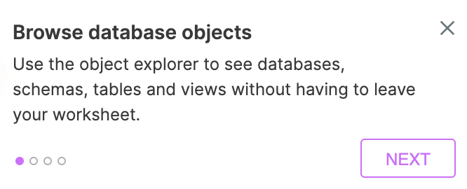

1. Change your Context to ACCOUNTADMIN.

1. Click on the Account button in the top middle of the Web UI.

1. Click on the Users tab.

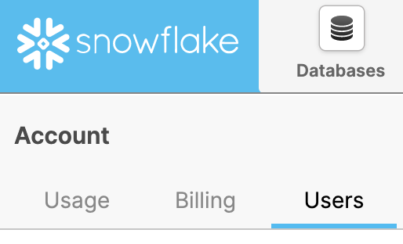

1. Click on the Create button.

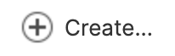

1. Fill in the required General fields to create a new user named SNOWMAN, and click on the Next button.

1. The Advanced information is not required, but you may fill it out of you would like to. Then click on the Next button.

1. Change the Default Role to SYSADMIN under Preferences, and click on the Next button.

1. Open a new tab within the Web UI by clicking on the +.

1. Enter the following SQL command, click on the Run button, and verify that the statement completed successfully.

grant role accountadmin to user snowman;

1. Launch a new tab in your browser, and connect to your Trial Snowflake URL.
2. Login with the User you created above.

1. If you did not uncheck the Force Password Change check box on the General tab, change the password for your new user, and click on the Finish button.

1. Close / Minimize the informational messages as you did before starting in Step 4 above.
2. Click on the Databases tab.

1. Click on the Create button, type in a name for your Database, and click on the Finish button.

1. Click on the Worksheets button.

1. Change the local context in the SQL Worksheet to the Database you just created.

1. Type in the following commands in the SQL Worksheet.

create or replace table DAILY_14_TOTAL as

select *

from snowflake_sample_data.weather.DAILY_14_TOTAL;

create or replace table WEATHER_14_TOTAL as

select *

from snowflake_sample_data.weather.WEATHER_14_TOTAL;

1. Check the All Queries box.



1. Click on the Run button.

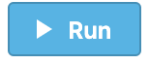

1. Click on the Open History button while the queries are executing.



1. Verify that both of the new tables were created successfully.

1. Open a new tab within the Web UI by clicking on the +.

1. Type in the following commands in the SQL Worksheet to create views of 2019 weather data.

create or replace secure view DAILY_14_TOTAL_2019_VW as

select *

from DAILY_14_TOTAL

where t >= to_date('01/01/2019','MM/DD/YYYY');

create or replace secure view WEATHER_14_TOTAL_2019_VW as

select *

from WEATHER_14_TOTAL

where t >= to_date('01/01/2019','MM/DD/YYYY');

1. Check the All Queries box.



1. Click on the Run button.



1. Click on the Open History button while the queries are executing.



1. Verify that both of the new views were created successfully.

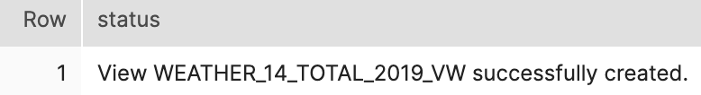

1. Go back to the Browser tab where the admin user is logged in.
2. Click on the Reader Accounts tab.

1. Click on the Create Reader Account button.

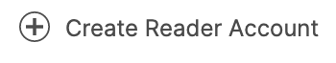

1. Fill out the Reader Account information as shown below, and click on the Create Account button.

1. Wait for the shared URL to be created.

1. Click on the URL created in the following window (Note – all URLs are unique and will not match the example below).

1. Log in with your newly created OLAF reader user.
2. Once logged in, click on the I’m A Data Consumer button.

1. Go back to the Admin user tab in your web browser, and click on the Done button.

1. Click on the Shares button.

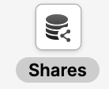

1. Click on the Outbound button.

1. Click on the Create button.

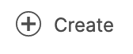

1. Fill in the Secure Share info as shown below, and click on the Create button.

1. Click on the Next: Add Consumers button.

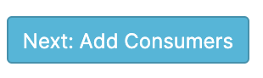

1. Select the Olaf reader account, and click on the Add button.

1. Click on the Done button.

1. Go back over to the Olaf tab in your browser.
2. Click on Warehouses button.

1. Click on the Create Warehouse button.



1. Fill out the Warehouse information as shown below, and click on the Finish button.

1. Change your Context to ACCOUNTADMIN.

1. Click on the Shares button.



1. Click on the Create Database from Secure Share link.

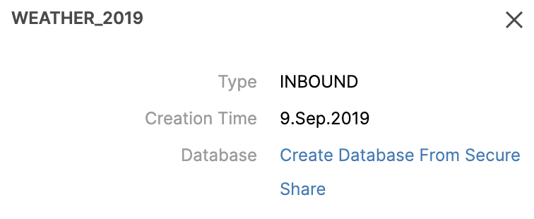

1. Fill out the share information as shown below, and click on the Done button.

1. Click on the OK button.

1. Click on the Worksheets button.

1. Click on the refresh button next to Find database objects, and your new database will appear.

1. Click on the shared FROSTY_DB_CONSUMER to expand the objects under the PUBLIC schema to preview the data.

